1. Maximum Subarray :
#CODE:
class Solution {
public int maxSubArray(int[] nums) {
int currentSum = nums[0];
int maxSum = nums[0];

for (int i = 1; i < nums.length; i++) {
currentSum = Math.max(nums[i], currentSum + nums[i]);
maxSum = Math.max(maxSum, currentSum);
}

return maxSum;
}
}

OUTPUT:
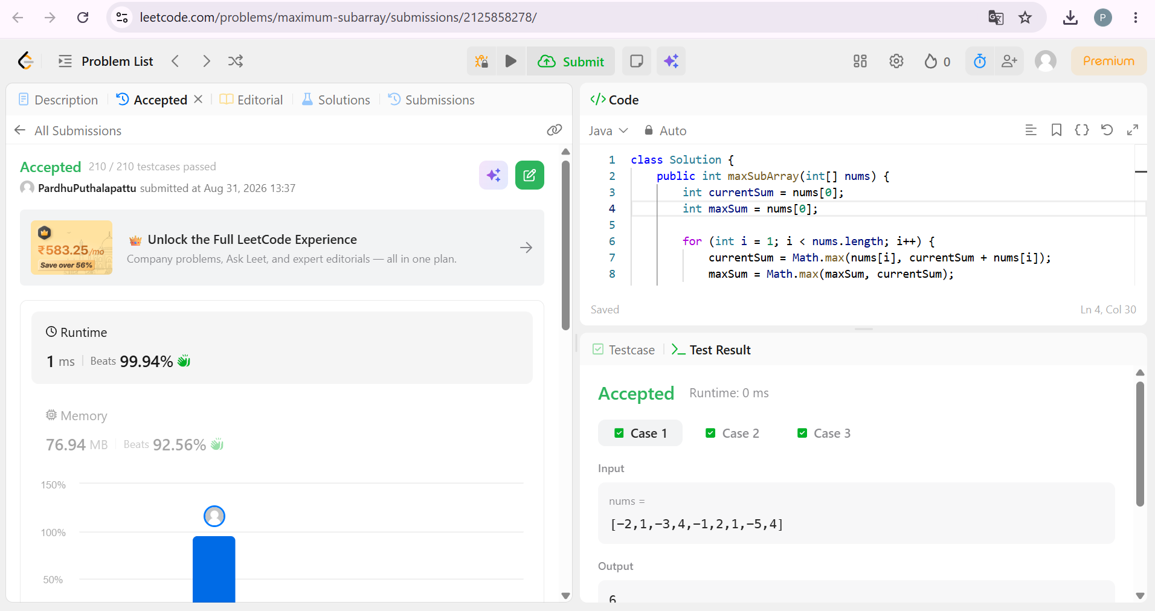

2. Find the Highest Altitude :
#CODE:
class Solution {
public int[] shuffle(int[] nums, int n) {
int[] ans = new int[2 * n];

int j = 0;

for (int i = 0; i < n; i++) {
ans[j] = nums[i];
ans[j + 1] = nums[i + n];
j += 2;
}

return ans;
}
}

OUTPUT:
